Candidate Information Pack

Chief Executive Officer
£48,000 - £50,000

Full-time, Initial 15 month contract

Please find

- Background Briefing
  - About cohousing
  - About the UK Cohousing Network
  - Organisational context
- About the role
- About you
- The Recruitment Process
- Application Form
- Equal Opportunities Monitoring Form

For background information on the UK Cohousing Network visit
https://cohousing.org.uk/

Background briefing

Why join us?
Would you like to lead an inspiring network that is supporting a growing movement of people choosing to create and manage their own communities? Would you enjoy working autonomously and with partner organisations to develop an emerging business? We are looking for a dynamic and entrepreneurial individual able to lead and shape the movement, who will enjoy getting stuck into a wide variety of tasks,working collaboratively to see more successful cohousing communities in the UK. You will be employed as the Chief Executive of UK Cohousing Network but with delegated duties from the UK Cohousing Trust, a recently formed charity with complementary educational and research objectives.

About Cohousing
Cohousing communities are created and run by their residents. Each household has a self-contained, private home but residents come together to manage their community and share activities, resources and skills. Cohousing is a way of combating the alienation and isolation many experience today, and a way that some groups with specific interests organise themselves as an intentional community, for example, older age, LGBT, climate activists, various belief systems, or simply as an intergenerational group of people who have a shared ethos to live in a more neighbourly way.
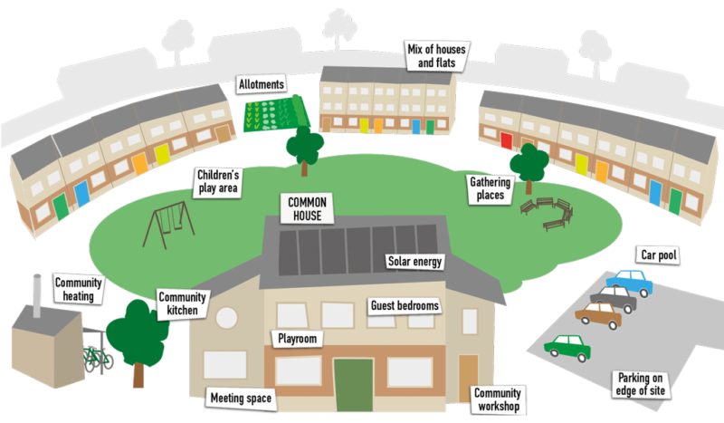
Cohousing communities are formed on the basis of a set of six primary principles:
Co-creating a community of people and place
Community members use the processes of co-design and co-production to create an intentional and purposeful community
Resident control and stewardship
Community members embed collective ownership, control and management by residents into their legal form and everyday decision making
Shared and private facilities
Community members use their shared and private spaces and resources to maintain a balance between communality and privacy
Human scale

The size and scale of cohousing is appropriate to support community dynamics for easy, informal communal contact; this is usually between 10-40 households.
Healthy living
Community members promote the health and wellbeing of their fellow residents through neighbourly contacts, and more sustainable ways of living together

Generous citizenship
Community members play a role in the life of the wider community, are welcoming to others, and help ensure that no one is lonely

Cohousing is a global definition for a way of living in socially active, self-managed communities and is gaining increased traction and interest from the public, particularly as a response to issues of loneliness and isolation and the public policy challenges of social care.

Read more about cohousing

About the network
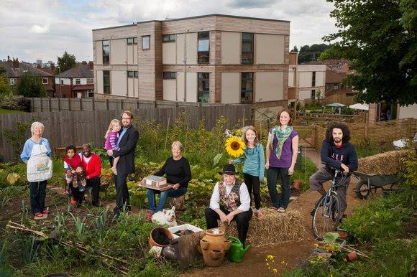
The UK Cohousing Network (UKCN) was established following the UK’s first Cohousing Conference in 2007. UKCN is the national cohousing membership organisation with a mission to enable communities to use the cohousing principles to create better places to live by sharing facilities and services to reduce isolation, loneliness and living costs. UKCN currently has 150 members comprising established, forming and developing groups across the UK.
UKCN is a resource for anyone interested in learning about cohousing, alongside an advice service for local councils, housing associations, and others working for progressive social change.

UKCN aims:
- Promote the widespread adoption of cohousing as a desirable, practical and mainstream housing choice for anyone who wants it
- Become a proactive enabler of new and retrofit cohousing projects to speed up groups’ ability to progress from group formation to moving into their new community
- To increase the skills and self-confidence of people who want to adopt cohousing principles in existing accommodation.
- Champion cohousing principles in mainstream public policy making

Our members’ manifesto, crowd-sourced at a recent UKCN Conference, placed new emphasis on:
- Genuine affordability for all
- Support for rental as well as ownership forms of tenure
- Joint working with other community housing organisations

Read more about the Network

Organisational context
The UK Cohousing Network is a small organisation with significant influence. We believe that cohousing can achieve more than simply living with shared facilities, but that the social bonds created can combat many of the ills of an increasingly fragmented and individualistic society.

In recent years we have adopted the following strategies to meet our aims, which will need to be nurtured and developed by the new CEO:

Working with and for the UK Cohousing Trust: we believe that research that fosters more cohousing communities can help deliver wider societal benefits, which is why the Network aimed to set up a sister organisation: the UK Cohousing Trust. The Trust’s purpose is to advance education for the public benefit with regards to the social and environmental impact of community housing and housing design, including by conducting research and disseminating evidence of that impact. The Trust has recently gained charitable status. Read more about the Trust.

Community Led Homes Partnership: the challenges faced by cohousing communities are shared by communities who take other approaches to community-led housing (CLH) such as co-ops, community land trusts and development trusts. Therefore we have formed a collaborative partnership with a vision of an infrastructure for the sector, led by the sector, of four organisations to form the Community Led Homes partnership: the UK Cohousing Network (UKCN), the National Community Land Trust Network (NCLTN), Confederation of Cooperative Housing (CCH) and Locality

The programme has been funded by the Ministry of Housing, Community and Local Government (£6M), the Nationwide Foundation and Power to Change and we are seeking further funds to continue the programme.

Each partner leads on a different area of nationwide support with UK Cohousing Network leading on a National Advice Centre providing an enquiry line and a new website with introductory information, technical resources and sector data to support hubs, advisers and groups get housing projects off the ground and completed. Read more about Community Led Homes

In summary, the current focus of the UK Cohousing Network is to work in collaboration with the UK Cohousing Trust and the Community Led Homes partnership to deliver support and advice to our members, but to advocate for changes to policy and law that will enable the wider community-led housing sector to build their own homes and communities.

About the role
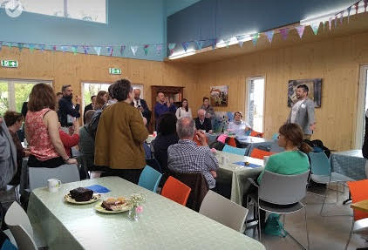
Working closely with our small and ambitious team, and with the other national partners, this role will work at a senior level to support the development of the Network, of cohousing and the wider community-led housing sector across the UK.

The CEO will have primary duties to the Network and Board of Directors, but will also be commissioned by the Trustees of the UK Cohousing Trust to develop, secure and manage research opportunities.

Purpose of the post
- Creating and realising a shared vision for the creation of more cohousing communities;
- Working closely with the boards to create a strategy to fulfil the vision and mission of both organisations and being accountable ensuring the team and contractors deliver on these objectives;
- Responsible for overseeing the day-to-day running of the Network and its activities, particularly membership;
- Delegated, complementary duties from the UK Cohousing Trust

Responsibilities and tasks
*(marked in brackets are the duties for each organisation)

- Strategy and Leadership (UKCN and UKCT)
- Collaboration, development and partnerships (UKCN and UKCT)
- As company secretary of the UK Cohousing Network, accountable for meeting legal obligations of running a company and accountable to the board;
- Accountable for the delivery of the work streams of major programmes of work including the Community Housing Fund (CHF) and Housing in Communities Hands (HiCH), programme under the Community Led Homes joint venture, and co-ordinating the contributions of both organisations to the two programmes;
- Delegated tasks from the UK Cohousing Trust (UKCT) including:
  - To support the UKCT in fulfilling its obligations to the Charity Commission
  - Oversight of an Action Learning Manager for the Homes in Communities Hands programme.
- Membership services development and management (UKCN)
- People management (UKCN and UKCT)
- Communications, advocacy campaigning, policy and research (UKCN and UKCT)
- Operational effectiveness and financial management including new opportunities for joint working with other members of the Community Led Homes (UKCN & UKCT)
- Procurement, suppliers and facilities (UKCN & UKCT)
- Other

(Full job description available upon request)

The challenges and opportunities for this role in the coming year include:
- Recruiting new members of the board of directors - including the appointment of a new Chair
- Seeking out opportunities for consultancy and research projects, often following up links made by board and trustee members
- Commissioning a new initiative - the Community Living Innovation Programme to select and work with a member community to stimulate the Network by facilitating connections and peer learning events for existing cohousing communities and encourage the creation of more
- Making a success of the National Advice Centre and other projects and programmes to increase the likelihood of repeat funding.

Terms and Conditions
- Fixed term contract of 15 months (with the possibility of extension subject to successful fundraising)
- £48,000 to £50,000 FTE
- 30 hours over 4 days/week (with the possibility of extension to full time subject to successful fundraising)
- Location: hosted by National CLT Network at CAN Mezzanine, Great Dover Street, Southwark
- Extensive travel throughout the UK required, generous travel budget included.
- Probation period 6 months
- Notice - one month, after probation, two months
- Requests for flexible working will be considered

About you
We are looking for an energetic and collaborative leader to see the UK Cohousing Network thrive.

Skills and abilities
- You will have enthusiasm for leading, inspiring and empowering others, building confidence in the organisation;
- You will bring first-rate networking and communication skills;
- Able to take an entrepreneurial and innovative approach to strategy development;
- Strong strategic planning skills, able to develop vision encouraging others to contribute;
- Able to lead the organisation through periods of change, particularly in an evolving and challenging external environment;
- You will be able to assess risk and promote risk awareness without being risk averse;
- IT literate, comfortable with using MS Office and able to understand the potential of IT and digital communications to further the organisation.

Experience
- You should have extensive experience in a senior role, in one or more of these areas: community led housing, social housing, housing development, community development, planning, health and wellbeing, and have a genuine interest and curiosity in how all these relate to a thriving cohousing sector;
- You should be familiar with the legal, financial, governance aspects of running and developing a small social not-for-profit enterprise, ideally a membership network or charity;
- A proven track record of developing and sustaining effective partnerships with a wide range of stakeholders;
- You must be used to working autonomously, but also collaboratively; with members or clients, partner organisations, or voluntary board members. This will call for high levels of creativity, drive and energy, coupled with a willingness to travel extensively across the UK.

Personal qualities
- You will possess sound judgment, credibility, integrity;
- You will have the ability to listen, reflect and learn;
- You will also feel strongly about the importance of social cohesion and inclusion, and the difference that cohousing can make to people in every walk and stage of life.

This is an exciting opportunity to support the growth of the network and of cohousing in the UK. Whatever your motivations, we would like to hear from you — particularly if you enjoy immersing yourself in a new and emerging sector, like to drive change by working hands-on, and enjoy working collaboratively to spot and grab opportunities.

The Recruitment Process

Timetable
Application deadline | Wednesday 4th September 5pm
Panel interviews | w/c 9th September
Final Interview (if required) | w/c 16th September
Decision made & successful candidate notified | Mid September

To Apply
If you would like to apply for this role please:
- Complete the Application Form (on the next page) which comprises:
  - Personal details
  - Complete the Cover Letter this comprises two questions to form a covering letter. Pleasure ensure these do not exceed two pages of A4 at no less than point 10 font.
  - Declaration
- Equal Opportunities Monitoring Form (following the application form)
- Attach a CV outlining your career to date, with any academic and professional qualifications.

Please send your application form, cv and equal opportunities form, to our HR Manager Rachel Chance at office@cohousing.org.uk. Please state CEO Job Application as the subject. PDFs preferred format.

Information
If you require any further information or you would like to discuss anything in more detail, please email office@cohousing.org.uk to arrange a telephone appointment.

UK Cohousing Network Application Form
Please complete this Application Form [please delete the preceding pages] and the Equal Opportunities Monitoring Form and attach a CV outlining your career to date, plus any academic and professional qualifications.
Please send your application, by 5pm on Wednesday 4th September 2019 to office@cohousing.org.uk

A: Personal details
Full name:
Address:
Mobile phone:
Home phone:
Email:

How did you hear about this post?

Are you eligible to work in the UK? Y/N

Please give details of your current income and benefits details:
Basic Annual Salary: Annual Leave:
Pension: Employer contribution: Employee contribution:
Any other benefits:
Notice required:

References
Please give details of two professional referees: your current or most recent, and a previous employer:

Current/most recent employer’s name:
Professional relationship to you:
Tel:
Email:
OK to approach: Yes/No

Previous employer’s name:
Professional relationship to you:
Tel:
Email:
OK to approach: Yes/No

B: Covering letter
On no more than two pages (and font no less than point 10), please state:

1) Why you would like to be the Chief Executive Officer of the UK Cohousing Network?

2) The experience and skills you can bring to this role in relation to the job description and person specification?

C: DECLARATION
I declare that the information that I have provided on this form is true and accurate, and in particular that I have not omitted any fact which may have a bearing on my application. I understand that any subsequent contract of employment with the UK Cohousing Network will be made on the basis of the information I have provided. I understand that a false declaration, which results in my appointment to UK Cohousing Network, will render me liable to dismissal without notice. I also understand that submitting this form electronically is equivalent to a signed declaration.

Signature [type your name] _____________

Date ___________

Equal Opportunities Monitoring Form
Strictly confidential
In order to help us ensure that our equal opportunities policy is being carried out we would be grateful if you could complete all parts of this form. The information given will be kept strictly confidential and used only for monitoring purposes. It will not be used as part of the selection process.

1. Gender What is your gender?

2. Disability
A disabled person under the Act is anyone with “a physical or mental impairment which has a substantial and long term effect upon his/her ability to carry out normal day to day activities”. Do you consider you have any disability as defined under the Disability Discrimination Act 1995? Yes [ ] No [ ]
If you answered ‘Yes’ please describe the nature of your disability:

If you are registered as disabled, please give your RD number:
3. Age Please put an x the appropriate box
[ ] Under 25 | [ ] 25–34 | [ ] 35–44 | [ ] 45–54 | [ ] Over 54

4. Ethnic group
Please put an x in the appropriate box to indicate your cultural background (categories taken from 2001 census).
Asian or  Asian British | Black or  Black British | Chinese/other ethnic group | Mixed | White
[ ] Indian  [ ] Pakistani  [ ] Bangladeshi  [ ] Other Asian background, please specify: | [ ] Caribbean  [ ] African  [ ] Other Black background, please specify: | [ ] Chinese  [ ] Other ethnic group, please specify: | [ ] White and Black Caribbean  [ ] White and Black African  [ ] White and Asian  [ ] Other Mixed background, please specify: | [ ] British  [ ] Irish  [ ] Other White background, please specify:

Thank you for completing this form

